Project Development Phase
Model Performance Test

Date | 30 September 2026
Team ID | MKU201Team76ab4df35a238dc999eb5e6de
Project Name | Streamlining IT Procurement: Automating Standard Laptop Orders with Flow Designer
Maximum Marks | 10 Marks

Model Performance Testing:
Project team shall fill the following information in model performance testing template.
S.No. | Parameter | Values | Screenshot
 | Metrics | Regression Model: Not applicable – no machine-learning model is used (rule-based Flow Designer automation).  Classification Model: Not applicable.  Process Metrics: Test orders placed - 1 (REQ0010002); Catalog Tasks created automatically - 1 (SCTASK0010002); Task-creation success rate - 100% (1 of 1); Manual steps needed to create the configuration task - 0. | 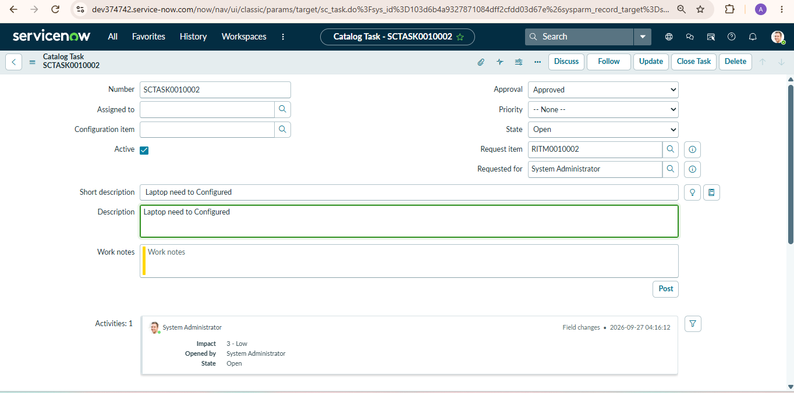
 | Tune the Model | Hyperparameter Tuning - Not applicable (no model training). Flow configuration finalised: existing automation removed from the Process Engine of the Standard Laptop item and the “Standard Laptop Task” flow selected.  Validation Method - End-to-end functional validation: order Standard Laptop → approve request → open Requested Item → verify Catalog Task (Short Description and Assignment Group). | 